AAAE Western Region

Leadership Manual
for
Officers and Chairs

Revised: 9/8/18

Contents
Introduction 1
Officer Terms 1
Dropbox 1
Web Sites 1
Timeline 1
President 3
Duties: 3
Vice-President 4
Duties: 4
Secretary 5
Duties: 5
Past President 6
Duties: 6
Research Committee 7
Purpose: 7
Committee Activities: 7
Terms: 7
Chair: 7
Professional Development Committee 8
Purpose: 8
Committee Activities: 8
Terms: 8
Chair: 8
Member Services Committee 9
Purpose: 9
Committee Activities: 9
Terms: 9
Chair: 9
Program Improvement Committee 10
Purpose: 10
Committee Activities: 10
Terms: 10
Chair: 10
Poster Session Chair 11
AAAE Poster Session Tasks 11
Call for Posters 14
Reviewers and Acceptance 14
Proceedings 14
Online Review System 15
Sample Screens for the Online Submission System 16
References: 20
Research Session Chair 21
Research Session Tasks 21
Proceedings 22
References: 23
Conference Chair 24
Common Elements 24
Financial Planning 24
Contracts 24
Posting Online 24
Venue Planning 24
Conference Schedule 25
Audio/Visual/Internet/Computer Access 25
Meals 25
Activity Planning 25
Timeline 26
Conference Packets 26
Name Tag Tools 26
References 27
Journal of Agricultural Education 28
Editing-Managing Board 28
Editorial Review Board 28
Appendix A – Constitution/Bylaws 29
Appendix B – Research Session 36
Format 36
Review and Selection Process 36
Deadlines and Due Dates 36
Research Paper Presentations * 37
Research Poster Presentations * 37
Awards 37
Research Conference Format Committee Members 37
Appendix C -- Western Region AAAE Award Guidelines 38
Awards 38
Tasks/Timeline 38
Awards Applications 38
Submission 39
Evaluation 39
Order Awards 39
Presentation 39
Appendix D – Award Submission System 40
Admin Menu 41
Submission List (admin) 42
Maintain Awards (admin) 43
Sample Excel Spreadsheet (admin) 45
Appendix E – Conference Location Rotation 46
Appendix F – Conference Registrations 47
Appendix G – Supplemental Documents 48
Appendix H – Research Proceedings Guidelines 49
Appendix H – Poster Session Guidelines 50

Introduction
This manual is designed to be a guide for Western Region Officers and Chairs. It should be considered a living document and revised regularly, as circumstances will change. New officers and chairs are encouraged to not only review the sections that pertain to their role, but to review the documents that guide the operation of the Western Region.

Officer Terms
In the Western Region officers advance through the chairs serving two years in each chair.

Dropbox
The region maintains a dropbox (WR Region) with historical files and resources. The dropbox is organized by role (ex. president, poster chair) and by year for conferences. Using the dropbox is an important part of the participation in the leadership of WR. It contains an archive of documents that can be used by future leadership.

Web Sites
AAAE maintains a web site (http://www.aaaeonline.org) with sections for the WR. They include:
- Conferences
- Proceedings
- Leadership (Officers, chairs, committee members)
The WR president has limited access to edit this site. Changes can be sent to the AAAE VP Communications. Calls for submissions and awards applications are maintained on this site.
Three additional web sites are used by the WR. They are:
- Fast-Track (http://aaae.expressacademic.org/login.php) for research papers. This site is managed by the AAAE manager.
- Poster Submission System (http://www.agedweb.org/AAAE/). This site is managed by the AAAE manager and used by the Poster Session Chair.
- Awards Site (http://www.agedweb.org/aaae/awards/). This site is used by the president and VP to accept award applications (see appendix for documentation).

Timeline
Month | President | Vice-President | Secretary | Past-President | Conference Chair | Research Session Chair | Poster Session Chair
October | Officer Meeting – Conference Review  Confirm Next year’s conference location. |  | Complete minutes  Post election results (officers, committees), Post awards
November
December
January | Officer Meeting | Revise award applications
February |  | Post awards applications and announce on list serve |  |  | Post basic info about the conference to the web site  Setup online registration with AAAE  Draft schedule complete | Call for abstracts
March | Call for proposals for national meeting (2020 for 2023, etc) |  |  |  |  |  | Revise Call and post on the submission site
April |  |  |  |  | Open Registration  Post draft schedule to the web site |  | Send First Call
May | Officer Meeting (at national) | Send award reminder to listserv |  |  |  | Select Reviewers | Send Second Call
June |  |  |  |  |  |  | Submission Deadline  Review Deadline  Author notification
July |  | Awards applications due  Choose evaluators and distribute applications |  |  |  | Abstracts due  Review complete and authors notified
August | Final Business agenda & distribute | Determine Awards | Send out minutes  Send out committee lists, responsibilities, and minutes sheets | Call for nominations for officers (even years) | Order Plaques |  | Prepare for conference  -Voting slips  -Poster Labels  Coordinate venue
September |  | Awards presentation  Post awards to the web site |  | Finalize officer nomination. |  | Complete Proceedings and post to web.  Tabulate, present awards. | Complete Proceedings and post to web  Tabulate, print, present awards

President

Duties:
- Participate as a voting member of the Executive Board for the American Association for Agricultural Education. This includes participation in the board meetings at the annual AAAE conference as well as quarterly conference call meetings.
- Along with other officers, plan the agendas for business sessions at the regional meetings.
- Conduct regional meeting business sessions.
- Coordinate with the local planning group to plan the Annual Western Region AAAE Meeting.
- Conduct the election of officers, committee chairs, and regional representatives.
- Solicit proposals for national meeting sites (every third year).
- Maintain list of regional meeting host state rotation. (See appendix.)
- Assist with national AAAE awards nomination and selection as directed by the AAAE Executive Board. (see appendix for procedure). Current responsibility is for:
  - Distinguished Extension Educator Award
  - Distinguished International Agricultural Educator Award
  - Outstanding Early Career Member Award

Treasurer
Since the regional accounting is kept by the national treasures the regional president is responsible for reporting back to the Region this balance of the regional account. Note: This information is regularly presented at national Board meeting which are attended by the President.

Vice-President

Duties:
- In the absence of the President, act in the official capacity of the President and perform all duties of that office.
- Coordinate the work of the committees
- Coordinate the Western Region AAAE Awards (see appendix)
  - Provide region meeting planning committee coordinator with budget for awards (plaques, certificates, etc.).
  - Update and send out nomination packets to AAAE list approximately 5 months prior to regional meeting with a nomination deadline of approximately 2 months prior to the meeting.
  - Post updated nomination packets to the AAAE website approximately 5 months prior to regional meeting.
  - Send a reminder to AAAE list 3-4 weeks prior to the nomination deadline.
  - Contact past winners of each award to serve as the selection committee. Send all nominations received for each award to the selection committee members. Ask them to respond by ranking the nominees. Set a deadline for selection committee response at least 3 weeks prior to the regional meeting.
  - Purchase plaques and certificates.
  - Make award presentations at the regional meetings.
  - Update awards record and post to AAAE website.
- Work with the secretary to write resolutions for conference and research hosts, etc.
- Propose resolutions in the last business session of the regional meeting.

Secretary

Duties:
- Coordinate with regional officer team to create agendas for the regional business meetings.
- Distribute agendas via email two weeks prior to the regional meeting.
- Post meeting agendas to the AAAE website two weeks prior to the regional meeting.
- Keep the minutes from the business meetings and post them to the AAAE website. This includes collecting committee meeting reports, organizing them, and including them in the minutes.
- Maintain a current list of regional officers and committee members.
- Update the western region leadership information on the AAAE website.
- Assist the vice-president in writing the resolutions thanking conference and research hosts, etc.
- Send resolutions to the appropriate parties.
- Secretary shall be responsible for correspondence of the Western Region, upon direction of the President and/or Executive Committee.

Past President

Duties:
- Serving in an advisory capacity to the President.
- Chairing of the Nominating Committee for officers and other elected positions.

Research Committee

Purpose:
The purpose of the Research Committee is to promote scholarly research and development activities among the membership that leads to advancing the professional of agricultural education.

Committee Activities:
To accomplish its purpose, the Research Committee is charged with the following:
- Promote dissemination of research through professional research meetings such as the National Agricultural Education Research Conference and regional research conferences.
- Identify individuals and/or departments to chair the regional research session.
- Recommend policies related to research conferences to facilitate the dissemination of research.
- Recommend policies related to dissemination of research through journals and other appropriate media.
- Coordinate the dissemination of research on the AAAE web site.
- Promote recognition of research and development activities of members.
- Carry out other activities related to research agreed upon by the membership.
- Foster collaboration within the region and communicate funding opportunities available for agricultural education research.
- Represent the region at the national meeting

Terms:
Members serve a two-year term with two members elected each year.

Chair:
Each year the committee will elect a chair. The chair is responsible for setting the agenda for the regional meeting and reporting to the membership the committee’s activity.

Professional Development Committee

Purpose:
The purpose of the Professional Development Committee is to plan, develop, and coordinate activities that enhance membership in the Western Region AAAE, provide for the growth and development of members, recognize members for exemplary contributions, and secure competent leaders for the organization to ensure effective and efficient operation of the organization.

Committee Activities:
To accomplish its purpose, the Professional Development Committee carries out the following activities:
- Secure nominations for Western Region AAAE office under the direction of the Past-President.
- Review the awards program and encourage nominations for appropriate awards.
- Provide leadership for determining, planning and implementing professional development workshops and in-service activities for members at the regional meeting.
- Develop and request annually from Western Region AAAE a budget for the committee’s activities.
- Carry out other activities related to professional development agreed upon by the membership.
- Represent the region at the national meeting

Terms:
Members serve a two-year term with two members elected each year.

Chair:
Each year the committee will elect a chair. The chair is responsible for setting the agenda for the regional meeting and reporting to the membership the committee’s activity.

Member Services Committee

Purpose:
The purpose of the Member Services Committee is to collect, summarize, and distribute appropriate information/data to the Western Region AAAE membership.

Committee Activities:
To accomplish its purpose, the Member Services Committee carries out the following activities:
- Develop opportunities to increase communication in the organization.
- Represent the region at the national meeting
- Encourage members to pay dues and update profiles so that communications can stay up to date.
- Post on the AAAE website the positions available in agricultural education. Assist the webmaster in deleting positions have been filled.
- Secure a list of individuals (with email addresses) that need access to the WR AAAE website for conference planning and other regional posting purposes. Submit the list to the webmaster within 30 days of the regional conference.
- Carry out other activities agreed upon by the membership and/or Executive Committee.
- Review and update the WR AAAE Constitution and Bylaws as they pertain to the Member Services Committee.
- Help make sure the Western Region listserv is up to date.

Terms:
Members serve a two-year term with two members elected each year.

Chair:
Each year the committee will elect a chair. The chair is responsible for setting the agenda for the regional meeting and reporting to the membership the committee’s activity.

Program Improvement Committee

Purpose:
The purpose of the Program Improvement Committee is to enhance existing programs, encourage and support new program initiatives, and provide agricultural leadership that will positively impact agricultural education.

Committee Activities:
To accomplish its purpose, the Program Improvement Committee carries out the following activities:
- The committee will identify special interest groups and facilitate collegial working relationships.
- Provide opportunities for collaboration within and outside of agricultural education.
- Serve as an advocate for improvement of teaching and learning in agriculture.
- Coordinate the regional Poster Session to facilitate the exchange of ideas and activities among the members.
- Carry out other activities related to program improvement agreed upon by the membership of the region
- Represent the region at the national meeting.
- Review and update AAAE Constitution and Bylaws as they pertain to the committee

Terms:
Members serve a two-year term with two members elected each year.

Chair:
Each year the committee will elect a chair. The chair is responsible for setting the agenda for the regional meeting and reporting to the membership the committee’s activity.

Poster Session Chair
The “Poster Session Chair” should be a member of the PI committee, but not necessarily the committee chair. Their responsibility is to organize and deliver the conference poster presentation. The will need to work with the Conference Chair to secure the venue and scheduling of the poster sessions.

AAAE Poster Session Tasks
The following task list follows the timeline milestones established in the Poster Session Guidelines. A menu of tasks is provided in the Poster System for the Conference Chair and Poster Manager. Tasks listed as the “Chair” responsibility will be completed by the Poster Chair
Timeline | Responsibility | Task | Notes
 | Web Master | End User Technical Site Support Issues | Issues where the site is not working (e.g.; error messages) should be referred to the web master. Login issues can usually be handled by the Manager.
 | Web Master/Manager | Chair’s Support
 | Chair | Determine Time Line | Set dates for submission, review, event.
 | Chair | Prepare the“CALL” | Call is created as a PDF file. See prior years for examples. Share the Call with the manager so web site can be prepared.
 | Manager | Setup Poster “Event” | In the poster submission system edit the dates for the timeline. Edit the Event and Submission requirements as needed. Check that the submission types are correct and review criteria are valid. This must be completed before submissions are accepted.
 | Manager | Call is posted on the submission web site | Using admin privileges in the poster submission system the Manager edits the event page to create a link to the Call on the AAAE web site. Note: The event is copied from a prior event and then dates and event information edited.
24 weeks | Chair | Disseminate the Call | Call is sent to AAAE list serve with the PDF file as an attachment. Send a copy to VP Comm for posting on the AAAE website under the conference
16 weeks | Chair | Email a second call with the PDF attached | Call is sent to AAAE list serve with the PDF file as an attachment
12 weeks | Manager | Confirm Eligibility | At least on author must be a member.
 | Manager | Recruit reviewers | Estimate the number of reviewers needed. Typically ½ of the submissions arrive the within 2 days of the deadline. Each poster abstract needs 3 reviews and reviewers can do 6-12 each.  Note: Email to the AAAE listserve as well as personal email to all of your friends!
 | Manager | Review Submissions (review copy) | Download the submitted files to a working directory. Search for identifying information (Word meta data) edit as needed. You may wish to disqualify abstracts that don’t follow the guidelines in fairness to those authors that do. Disqualified files may be assigned to the AAAE Reviewer and an explanation of the reason placed in the reviewer’s comments. Edited review copies are uploaded to the poster system as needed
 | Manager | Assign Reviewers | Add reviewers that are not already in the Poster system.  Each reviewer is assigned the poster abstracts to review in the poster system. Assign reviews following the “guidelines”. When assignment is complete it is suggested that you double check to see that each reviewer has a similar number and each abstract has enough reviewers. Once assigned you may use the Poster System to send an email to all reviewers that optionally will also send their individual login and password.
 | Chair | Determine how many posters to accept | Determine how many posters the venue can display and or how many you wish to accept. This is done in consolation with the conference planner (President).
 | Manager | Reviewer reminders | Generally remind reviewers 10 days before the deadline and 2 days before the deadline. Suggest phone calls for the 2 day follow up.
 | Chair | Additional Conference Coordination | In general the chair needs to work with the conference planners to establish the schedule. The program should list setup times (min. ½ hr ahead) and take down times.  Planning for purchase of the foam board and disposal should be coordinated by the chair, but best done by local folks. Foam can be purchased at any local home improvement store, dispose of the foam to a local ag/construction program or Habit for Humanity.
8 weeks | Chair | Accept Posters | All reviews must be completed before ranking is determined. The Poster system will calculate a mean score, a mean Z score (used for ranking) and rank by submission type. Use ranking and acceptance as primary criteria. In some cases the reviewers comments may help with acceptance.
 | Chair | Mark posters as accepted | In the poster system mark posters as accepted
 | Chair | Enable review viewing | Toggle this option in the poster system so authors can see reviews
7 weeks | Chair | Send email to authors | Use the poster system to send email or capture the email addresses. Send notices to accepted and not-accepted authors. As part of the acceptance notification it is suggested that the rules for display be sent to remind poster presenters. Revisions to the submitted abstract are submitted on the review page, a deadline should be provided.
 | Chair | Prepare the proceedings | Create an introduction with a basic report, Regional Winners, and Accepted posters. Combine the Introduction with the abstracts into a single document.
 | Chair | Share the accepted list with the conference chair | Print the accepted list from the poster system (word format) as distribute for the conference program
 | Chair | Prepare a conference report | See guidelines. Send copy to Secretary.
 | Chair | Prepare judging packets | Labels can be printed. Also need tickets for People’s Choice
2 weeks | Chair | Post the Proceedings | Proceedings are posted on the AAAE Web site under the meeting (conference) prior to the conference.
 | Chair | Contact Presenters | Remind presenters of the size requirement and recommendations for mounting posters to foam board. This may seem redundant but may save the hassle that a 6’ poster cannot be displayed.
 | Chair | Purchase certificates | Purchase certificate paper (3x the number of awards to allow for multiple authors) and presentation covers
 | Chair | Print card or sheets for posters (optional) | Used to organize the poster session. Cards show poster info as well as the needs for power, free standing, etc.
 | Chair | Order foam board | Determine how many posters will need a mounting board. Make arrangement with the conference organizer to have this purchased locally and dispose of it to a local Ag program or Habitat for Humanity.  Check on availability of a printer for certificates
Conference | Chair | Setup | Using the cards layout where each poster will be displayed OR just allow any place.
 | Chair | Breakdown | Remove boards and dispose of boards. Check conference schedule to see when this needs to happen. Inform presenters of a deadline.
 | Chair | Collect People’s Choice tabulate | Enter scores and double check. Determine winners. See downloadable spreadsheet.
 | Chair | Print certificates | Certificates can be printed directly from the tabs program or using other software. Print one for each author. Certificates are signed by Poster Chair and President. Print one per author. Typically we present the “Outstanding” poster to the highest score and “Distinguished” to 2nd and 3rd place.
 | Chair | Report results | Create a results report with a summary of the poster session and list the winners. Acknowledge the judges in the report. Send copy to Secretary and post on the AAAE web site under the Conference.
 | Chair | Present awards | Determine when this will be done. Be prepared to mail certificates if a winner is not present.

Call for Posters
The call for posters is normally sent out two or three times by email to the Western Region AAAE listserv. A PDF file is produced (see Appendix) that list the deadline and requirements. This file is also posted on the AAAE web site.

Reviewers and Acceptance
The poster manager handles the entire review process. The poster chair will be informed then the process is complete.
Reviews are ranked using the mean Z scores in with ideas and research ranked separately. Generally those posters at the top and bottom of the ranking are fairly clear. Posters in the middle often have mixed reviews. It is helpful to read reviewer comments and recommendations for these submissions.
Acceptance rates will very. At some meetings, the space for posters is limited and will determine the number of posters to accept. Often a natural break in the ranking will suggest a dividing line. Acceptance rates vary from 60-80%.
Once acceptance is determined the authors are notified. It is a good idea to remind authors of the poster size limits again.

Proceedings
Proceedings are created and saved as a PDF file for distribution. Request a final copy of each abstract.
Create a document in Word with the following:
- Cover Page
- Summary of the submission and acceptance
- Reviewers names
- Table of Contents (organized by type). This part of the document can be used for the conference program.
Import abstracts (in order) into the document. Note: You will have to reformat each paper as their formatting will not match your style.

Online Review System
Most of the poster process is automated in the online submission system. The poster manage will grant access to the chair. Documentation is available online for the functions of this system. The chair should review the options and be familiar with their use before the call is issued. The poster manager will provide support.

Submission
Users login and submit their narrative using the provided online form. Files are stored on the system. The user and the event administrator get a confirming email. It is recommended that the administrator save these and confirm that all posters are accounted for.

Review Analysis
A number of options exist for exporting the review data to Excel for analysis. The system automatically computes reviewer means and SD, Z scores, and ranking.

Accepting Submissions
A screen to mark accepted submissions is provided. A link to the reviews is also provided here should you wish to look at a set of reviews.
Once accepted posters are marked:
- Download (or view on the screen) the accepted list and double check. This document can be used for proceedings.
- Allow Review Viewing. This allows authors to see their reviews.
- Email the accepted authors using the link provided.
- Email the not-accepted authors

Sample Screens for the Online Submission System
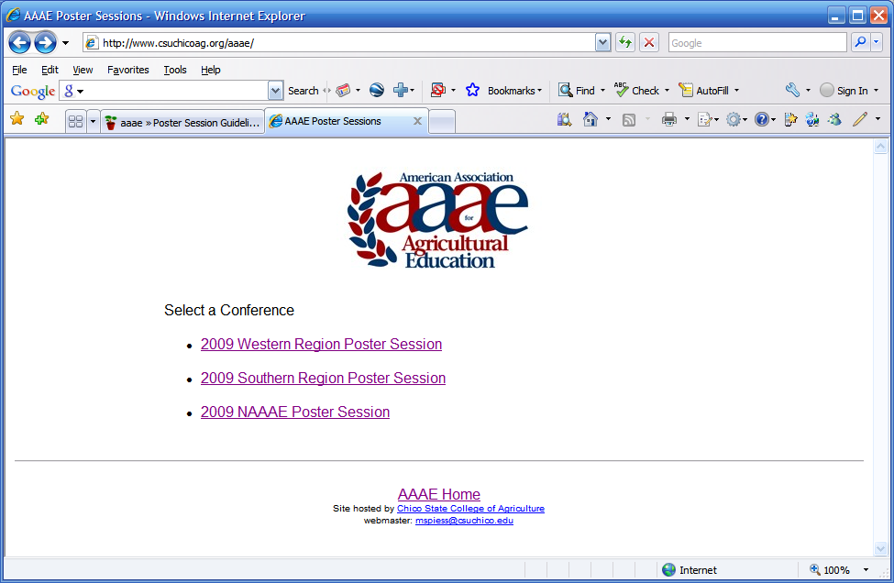
Opening screen. Only confereences (events) that occur in the future are listed.
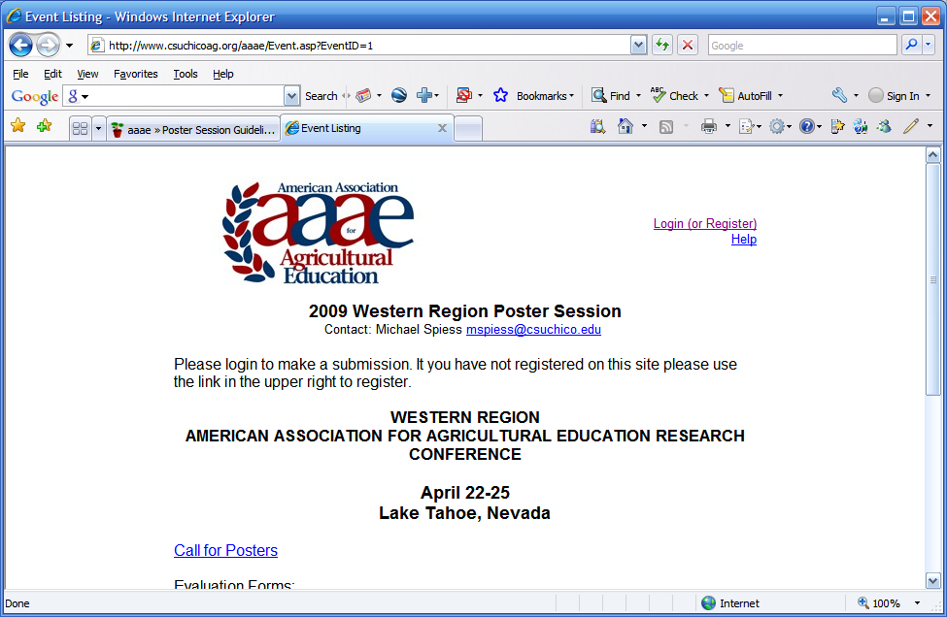
Conference screen. Text is taked from the event setup.
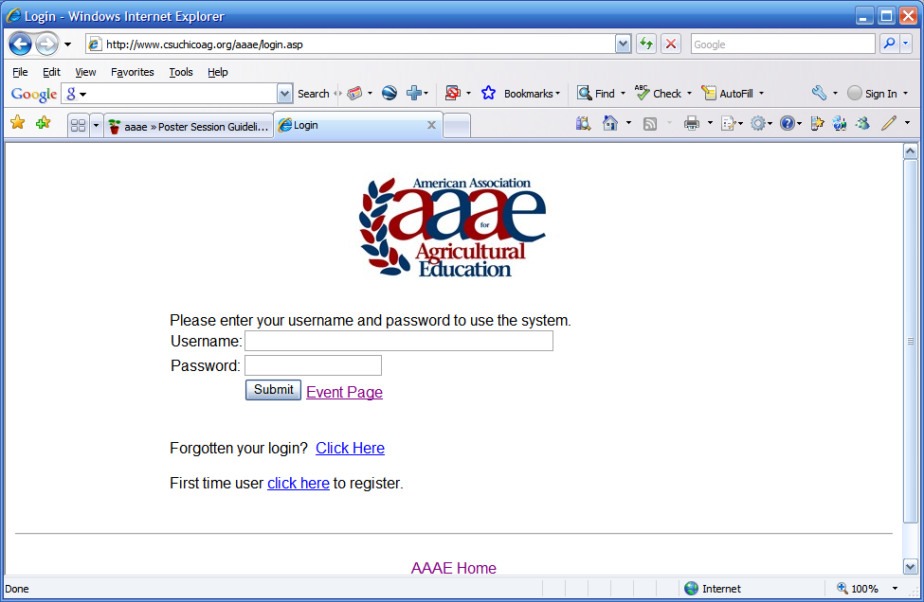
Login screen.
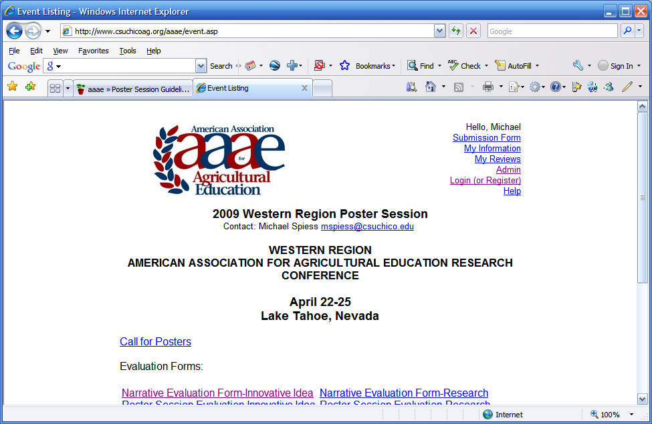
Event screen after login. Menu in upper right will vary depend on the role of the user.
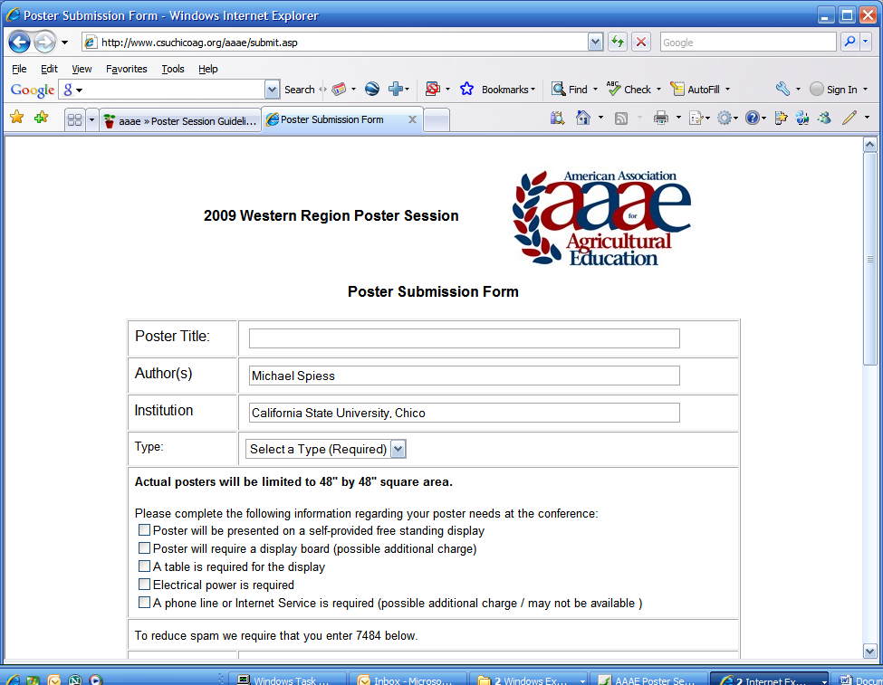
Submission form (upper half). Type is customized for the event, Author and Institution are defaulted from the user login information.
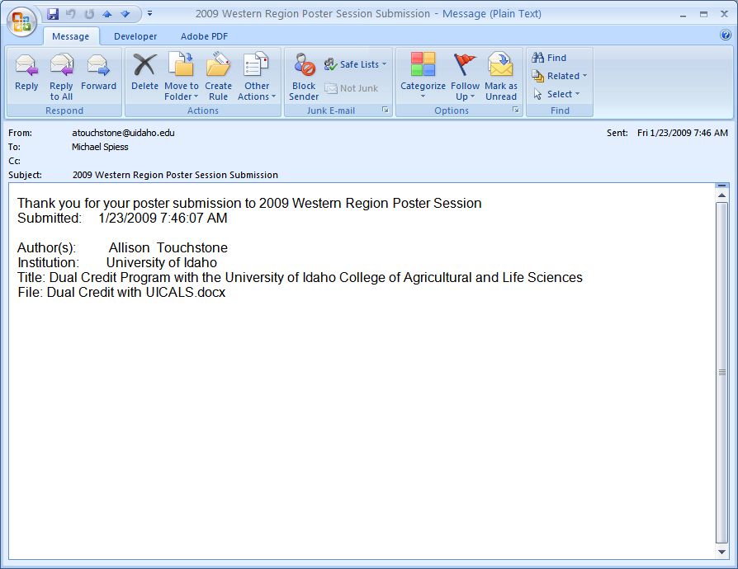
Confirmation Email
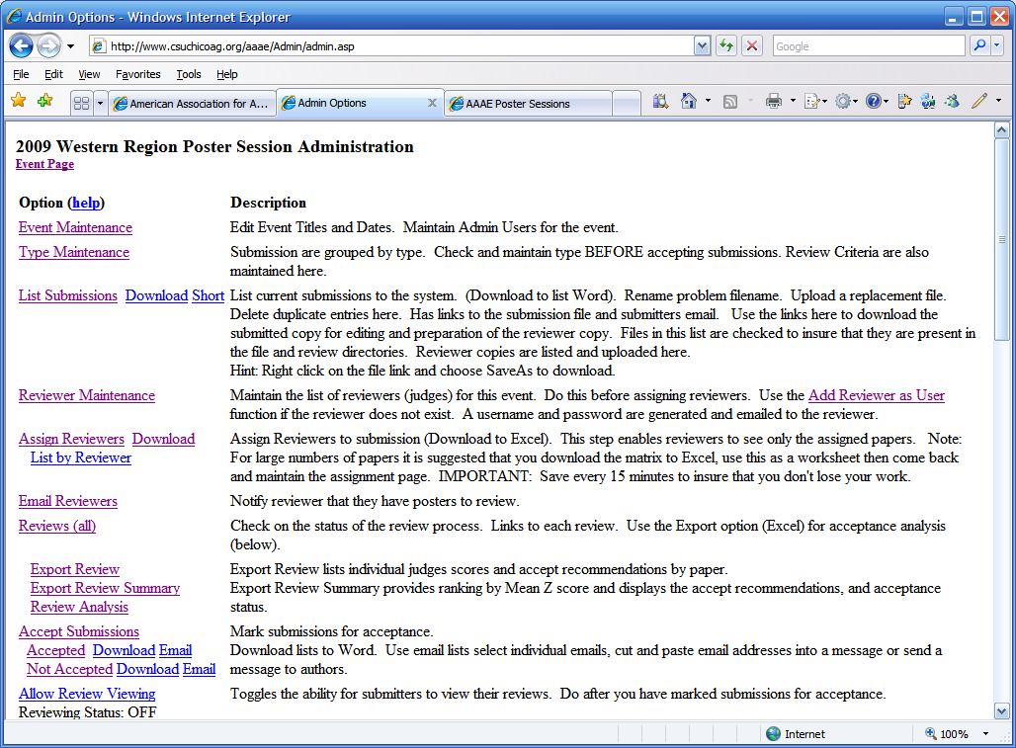
Admin Menu
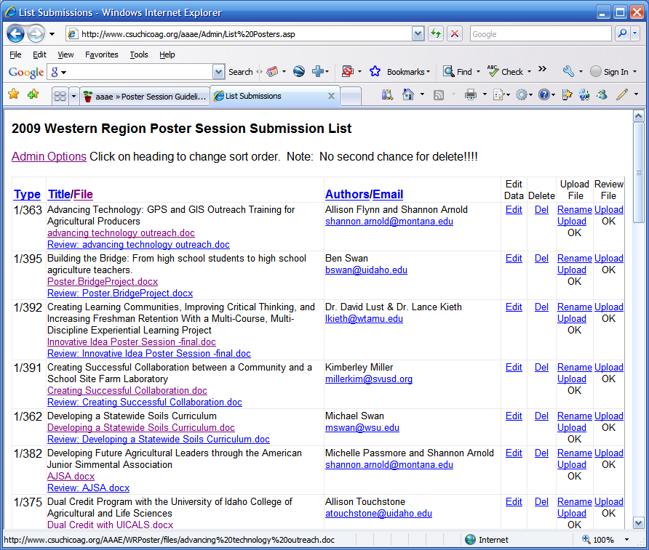
List Submissions screen
Options:
Edit | Allows editing of the submission information (e.g. title, authors)
Del | Deletes files and database entry for the submission. Useful when duplicates are submitted. WARNING: No second chance.
Upload
Rename | Use to rename a file that has an authors name or is poorly identified.
Upload | Use to upload a new file for the submission.
Status | OK - file exists (see filename under title), Missing - No file has been uploaded.
Review
Upload | Use to upload the reviewer copy (no cover page)
Status | OK - file exists (see filename under title), Missing - No file has been uploaded.

References:
AAAE Poster Session Guidelines
Poster Session Date Calculator.xlsx

Research Session Chair
The “Research Session Chair” should be a member of the research committee, but not necessarily the committee chair. Traditionally the chair is from the host institution. Their responsibility is to organize and deliver the conference research presentations. The will need to work with the Conference Chair to secure the venue and scheduling of the poster sessions.

Research Session Tasks
The following task list follows the timeline milestones established in the Poster Session Guidelines. A menu of tasks is provided in the Poster System for the Conference Chair and Research Paper Manager. Tasks listed as the “Chair” responsibility will be completed by the Poster Chair
- February 15: Call for abstracts issued
- March 1: Call for research poster proposals issued (Poster Chair?)
- June 1: Abstract due
- On or before June 15: Authors of abstracts notified of review results
  - Authors of paper submissions not accepted for presentation are encouraged to edit the abstract to meet the submission requirements for a research poster and submit for subsequent poster review.
- July 1: Research poster proposal due
- On or before August 1: Authors of research poster proposals notified of review results

Timeline | Responsibility | Task | Notes
 | Manager | Chair’s Support
 | Chair | Determine Time Line | Set dates for submission, review, event.
 | Chair | Prepare the“CALL” | Call is created as a PDF file. See prior years for examples.
 | Manager | Setup Poster “Event”
February | Chair | Disseminate the Call | Call is sent to AAAE list serve with the PDF file as an attachment. Send a copy to VP Comm for posting on the AAAE website under the conference
April | Chair | Email a second call with the PDF attached | Call is sent to AAAE list serve with the PDF file as an attachment
June | Manager | Confirm Eligibility | At least on author must be a member.
 | Manager | Review Submissions | Submissions should be void of identifying information.
 | Manager | Assign Reviewers | NOTE: The research committee selects 5 reviewers to review all papers
 | Chair | Determine how many papers to accept | Determine how many papers can be presented at the venue. This is done in consolation with the conference planner.
 | Manager | Reviewer reminders
 | Chair | Additional Conference Coordination | In general, the chair needs to work with the conference planners to establish the schedule. .
 | Manager | Supply the chair with the completed review data.
July | Chair | Accept Paper | Using the supplied spreadsheet determine which papers will be accepted
 | Chair | Send email to authors
August | Chair | Prepare the proceedings | Create an introduction with a basic report, Regional Winners, and Accepted posters. Combine the Introduction with the abstracts into a single document.
 | Chair | Develop Themes | Based on the accepted papers determine themes for the research sessions.
 | Chair | Share the accepted list with the conference chair | Prepare a program by theme for distribution with the conference program
September | Chair | Prepare a conference report | Should summarize submissions, acceptance, reviewers, etc. Send copy to Secretary.
 | Chair | Post the Proceedings | Proceedings are posted on the AAAE Web site under the meeting (conference) prior to the conference.
Conference | Chair | Determine awards winners
 | Chair | Present awards | Determine when this will be done.

Proceedings
Proceedings are created and saved as a PDF file for distribution. Request a final copy of each paper/abstract.
Create a document in Word with the following:
- Cover Page
- Summary of the review process
- Reviewers names
- Research Conference History
- Table of Contents (organized by session). This part of the document can be used for the conference program.
Import papers/abstracts (in order) into the document. Note: You will have to reformat each paper as their formatting will not match your style.

References:
(Past Proceedings and Schedules)

Conference Chair
The conference chair is responsible for the planning of the conference. Each conference is somewhat unique in that adjustments need to be made for facilities, desired activities, and the unique nature of the location.

Common Elements
Each conference has common elements:
- Business Sessions
- Research Sessions
- Poster Sessions
- Tours/Speakers (PD)
- Committee Meetings
To some extent these are flexible in scheduling. See prior years.

Financial Planning
The conference should be planned to break even. There are some fixed costs that must be factored in addition to conferences:
- Awards (plaques) ($100)
- Research Reviewer Stipends ($1000)
- Poster Board ($100)
All registration revenue will be collected by AAAE and all expenses paid by the AAAE Treasurer. When possible send invoices directly to the treasurer. Reimbursement requests should be sent to the treasurer with the original billing (receipt) and complete remittance information.

Determining Registration Fees
The fee structure is based on faculty and student rates. Late fees may also be charged, but should not be used in planning total revenue. A spreadsheet is available for planning fees. Variable costs such as meals are not hard to plan for as they will track registrations. However covering the fixed costs requires some estimate of attendance. This is somewhat variable. Reviewing attendance from previous conferences may help.

Contracts
If a contract is needed then is should be signed by ???????????????? (Need to check on this.)

Posting Online
More information is better! Suggested information:
- Which airport to fly to (there may be options).
- Ground transportation options from the airport. For example, does the hotel have a shuttle.
- General tourist information for folks wishing to arrive early or stay late
- How to register at the hotel (generally a conference rate requires a code).
- Any general “local” information that will aid folks in planning.

Information on the conference such as the calls, conference schedule, and registration are posted to the AAAE website. Submissions should be sent to

Venue Planning
Space requirements vary for each element.
Meeting Type | Setup | Media
General Session | Classroom, podium, tables are nice for note taking. | Projector, connectivity to provided laptop
Poster Session | See Guidelines. It is desirable to allow posters to remain on display for more than just the session to foster additional communication and collaboration. | None
Research Session | See Research Guidelines. Each concurrent session will require a room with projector and a round discussion table for each paper in the session. Total length will be dependent on the number of papers in the session. | Projector, Screen, laptop
Committee (4) | Tables/Chairs for small groups. Larger room can be shared. | None

Hotels commonly will base meeting room costs on “nights” of stay. Not all participants will stay at the hotel. Commonly, a block of rooms are reserved for the conference at a preferred rate. How this works specifically will vary by hotel. If university rooms are used this may lower the cost. From a networking standpoint using one hotel is desirable.

Conference Schedule
It is ideal to get a draft schedule out early so folks can plan arrival and departure times. The draft schedule need not be highly detailed. Schedules from prior conferences are a good starting point. See Dropbox or the web site for prior years.

Audio/Visual/Internet/Computer Access
In most cases we will need the means to project PowerPoint. Most hotels provide for a fee. We can save money by providing our own equipment. Having Wi-Fi access in the meeting spaces and in the rooms is desirable. This may be an extra charge or part of the service.
While we can bring printed materials we generally will need a way to print on-site. Some hotels have a business center or the host can bring a computer/printer.

Meals
Meal planning is quite variable by conference. Some factors to consider:
- Cost
- Availability of meals at the hotel (ex. breakfast might be included)
- Combining meals with activities (like the tour, poster sessions or awards)
- Availability of meals near the hotel for “one your own” meals. Not all folks will have transportation.

Activity Planning
PD activities are commonly speakers and/or tours. The Conference Chair should work with the PD committee (chair) to develop and schedule these types of activities. A small budget is available from National AAAE for this purpose.
Poster Sessions should be coordinated with the Poster Session Chair.
Research sessions should be coordinated with the Research Session Chair.

Timeline
Month | Activity
September | Present at WR Conference (5 min update)
October
November
December | Determine schedule needs (especially with special meetings)
January | Budget??
February | Develop Draft Schedule
March | Post details to web site, open registration, announce to listserv
April
May
June
July
August | Order Awards (VP), Coordinate with Poster Chair
September | Conference

Conference Packets
A conference packet should consist of:
- Schedule – Note: Placing a small version in the nametag is very useful as a quick reference.
- Name Tag -
- Research and Poster List (not proceedings)
- Consider a portfolio with paper and pen?
- Other references may include.
  - Committee assignments
  - Action item references
  - Other materials provided by the officers
  - Maps to local eating (for on your own meals)
  - Map to meeting venues (if off site)
  - Information on tour sites (often can be provided by site)
- Meal and voting tickets (posters)

Name Tag Tools
- Download Attendee List (VP Comm)
- Edit List to fix typos
- Mail Merge to Name Tags (template)
- Schedule can be added. See template.
http://www.mybadges.com/conference-id/name-badge-holders-name-tags/vertical-badge-holders/
http://www.idcardgroup.com/holders/convention/largehangingticketbadgeholder

References
(Budget Spreadsheet)
(Facilities Spreadsheet)
(Name Tag Schedule Doc)
(Sample Conference Schedules)

Journal of Agricultural Education
There are two main bodies in the Journal that have regional representation: The Editing-Managing Board and the Editorial Review Board

Editing-Managing Board
1. The Journal shall be published under the oversight of the Editing-Managing Board.
- The Editing-Managing Board shall consist of three members from each of the three regions of the AAAE. Regional board members will be elected at regional business meetings and serve staggered three-year terms.
- Board terms and all offices serve on a calendar year.
- The Editing-Managing Board of the Journal shall make an annual report to the AAAE.
- The nine member board will elect a chair and secretary at the annual meeting. Officers will serve a one-year term.
- The editor, past editor and regional editors shall be invited to attend meetings and provide information but shall not be voting members.
2. The duties of the Editing-Managing Board shall include:
- Appointing the Editor for the Journal.
- Cooperating with the editor to insure that the Journal is a refereed publication.
- Advising the editor concerning any matters which he/she may refer to the board.
- Establishing such policies as may be deemed necessary for the orderly development and publication of the Journal.
- Making the decision as to the number of issues to be published in a given year considering the recommendations of the AAAE and the editor of the Journal.
- Establishing subscription rates for the Journal for those agencies and individuals of AAAE.

Editorial Review Board
The Editorial Review Board will be used in reviewing articles for the Journal. The following procedures will be followed to establish and continue the Editorial Review Board:
- There will be 18 members of the editorial board.
- Six members will come from each AAAE region.
- Members will be nominated by the regional representative of the Journal Editing-Managing Board.
- Members will be approved by a majority vote of the entire Editing-Managing Board.
- Each member will serve a three-year term.
- The member terms will be staggered initially by randomization of one, two, and three year terms of membership among the regional members.

Appendix A – Constitution/Bylaws
Constitution of the Western Region of the
American Association for Agricultural Education
Adopted September 2013
ARTICLE I NAME
Section 1. The name of the organization shall be "Western Region American Association for Agricultural Education." The name “Western Region” may be used herein in lieu of the complete name of the organization.
Section 2. The Western Region is a regional affiliate of the “American Association for Agricultural Education,” herein referred to as “AAAE.” As such, the Western Region will operate under the guidelines, procedures, and practices of AAAE, except as noted herein.
ARTICLE II PURPOSE
Section 1. Mission: The mission of the Western Region is congruent with the mission of its parent organization, the American Association for Agricultural Education. The AAAE mission is to advance the broad field of study which integrates social and behavioral sciences with agricultural, life, environmental, and natural resource sciences. Scholarship within the field of study is additive to the knowledge bases of planning and needs assessment; curriculum development; learning theory; instructional design; delivery strategies; evaluation; research methods and tools; scholarship and writing; history, philosophy and ethics; and contextual applications, culture and diversity. Our context for scholarship and practice include teacher education, international agricultural education, extension education, agricultural communications, distributed learning, higher education, and leadership education.
Section 2. Goals: The Western Region will accomplish its mission by:
- serving as an advocate for the improvement of teaching and learning in agriculture.
- providing a forum to address issues in agricultural education.
- providing an approach to identifying, prioritizing, and organizing research in agricultural education.
- providing opportunities for individual and organizational growth, development, and renewal.
- providing opportunities to communicate the results of research and other scholarly activities.
- providing opportunities for collaboration within and outside of agricultural education.
- providing for recruiting, inducting, and mentoring people into the profession.
Section 3. Values: As a professional organization, we value:
- high quality instruction in the total formal and nonformal agricultural education system.
- developing and empowering individuals.
- actively engaging learners/experiential learning.
- high quality research and other scholarly activities.
- an active role in contributing to both formal and non-formal educational systems.
- professional renewal and adjusting to change.
- collaboration and networking.
- the critical role of agriculture and natural resources in our nation's welfare
- a public that is informed about trends and issues in the agricultural industry
ARTICLE III STATES AND TERRITORIES
Section 1. States and territories comprising the Western Region shall be defined by AAAE.
ARTICLE IV MEMBERSHIP AND DUES
Membership in the Western Region may be granted and maintained as defined in Article IV of the AAAE Constitution and Bylaws. Upon acceptance as a member in AAAE, members from states and territories comprising the Western Region, as defined by AAAE, shall be considered members of the Western Region.
ARTICLE V OFFICERS
Section 1. The officers of Western Region shall be President (who shall serve as the AAAE Regional Vice President), Vice President, Secretary, and Past-President.
Section 2. Only Active Members may serve in leadership positions.
Section 3 The term of office for officers shall be two years. The Past President shall be succeeded by the President, President by the Vice President, and Vice President by the Secretary. The Secretary shall be elected by majority vote of those present and voting at the annual meeting. Nomination, election procedures, and duties of officers shall be as described in the Bylaws.
ARTICLE VII VOTING
Section 1. All classes of membership are eligible to attend and participate in discussions of Western Region business, but only Active Members are eligible to vote.
ARTICLE VII COMMITTEES
Section 1. Standing Committees will follow those committees designated by the AAAE bylaws that specify regional representation.
Section 2. Committees may be appointed as deemed necessary by the President and/or Executive Committee.
ARTICLE VIII MEETINGS
Section 1. The annual meeting of the Western Region shall be held at such time and place as the membership shall decide. Host states will be determined as outlined in Article V, Section 1 of the Western Region Bylaws.
Section 2. Notice of the annual meeting shall be made to the membership in writing or electronically via email and/or listserv at least 60 days prior to the annual meeting.
ARTICLE IX AFFILIATION
Section 1. The Western Region may affiliate with other organizations upon majority vote of the Active Membership or of those present at the annual meeting, providing such affiliation is not in violation of AAAE policies.
ARTICLE X PARLIAMENTARY AUTHORITY
Section 1. The rules contained in the current edition of Robert’s Rules of Order Newly Revised shall govern the organization in all cases to which they are applicable, and in which they are not inconsistent with this constitution and bylaws and any special rules of order the organization may adopt.
ARTICLE XI AMENDMENTS
Section 1. This Constitution may be amended by two-thirds of the Active Members present and voting at any annual meeting provided that:
- Proposed amendments are submitted to the Executive Committee at least 60 days in advance of the annual meeting.
- The Executive Committee has submitted proposed amendments to the membership in written or electronic form no later than 30 days before the annual meeting.
Section 2. Amendments may be proposed by the Executive Committee, by committee recommendation, or by any Active Member.
ARTICLE XII DISSOLUTION
Section 1. On dissolution of the Western Region, the Executive Committee shall pay or make provision for the payment of all of its liabilities. Any remaining assets will become the property of AAAE.
Bylaws of the Western Region of the
American Association for Agricultural Education
Adopted September 2013
ARTICLE I ELECTION OF OFFICERS
Section 1. Officers shall serve an eight year term, rotating through the offices from secretary, vice president, president, and finally past president.
Secdtion2. The President, with the approval of the Executive Committee, shall appoint a nominating committee which will be chaired by the Past President. The nominating committee shall prepare a slate of candidates for Secretary of the Western Region and any other offices that have been filled by appointment (see Article II). The nominating committee shall submit its report to the Executive Committee prior to the first session of the annual meeting.
Section 3. Nominations for any elective offices of the Western Region may be made from the floor.
Section 4. Voting for election of Western Region officers shall be by secret ballot during the annual meeting.
ARTICLE II VACANCIES
Section 1 Should the President leave the region or profession, or for other reasons become unable to fulfill the duties of the office, such office shall be declared vacant immediately and be filled by the Vice President until the next meeting of the Western Region.
Section 2 Should the Vice President or Secretary leave the region or profession or for other reasons become unable to fulfill the duties of the office, such office shall be declared vacant immediately and the vacancy shall be filled by action of the Executive Committee until the next meeting of the Western Region.
Section 3 Should the Past President leave the region or profession, or for other reasons become unable to fulfill the duties of the office, the office shall be filled by the most recent Past President available, or if needed, filled by action of the Executive Committee until the next meeting of the Western Region.
Section 4 Should any member of a Standing Committee leave the region or profession, or for other reasons be unable to fulfill the duties of the committee, such position shall be declared vacant immediately and be filled by the President.
ARTICLE III DUTIES OF OFFICERS
Section 1. The President’s duties shall include:
- Participate as a voting member of the Executive Board for the American Association for Agricultural Education. This includes participation in the board meetings at the annual AAAE conference as well as quarterly conference call meetings.
- Along with other officers, plan the agendas for business sessions at the regional meetings.
- Conduct regional meeting business sessions.
- Coordinate with the local planning group to plan the Annual Western Region AAAE Meeting.
- Conduct the election of officers, committee chairs, and regional representatives.
- Solicit proposals for national meeting sites (every third year).
- Maintain list of regional meeting host state rotation.
- Assist with national AAAE awards nomination and selection as directed by the AAAE Executive Board.
Section 2. The Vice President’s duties shall include:
- In the absence of the President, act in the official capacity of the President and perform all duties of that office.
- Coordinate the work of the committees
- Coordinate the Western Region AAAE Awards
    - Provide region meeting planning committee coordinator with budget for awards (plaques, certificates, etc.).
    - Update and send out nomination packets to AAAE list approximately 5 months prior to regional meeting with a nomination deadline of approximately 2 months prior to the meeting.
    - Post updated nomination packets to the AAAE website approximately 5 months prior to regional meeting.
    - Send a reminder to AAAE list 3-4 weeks prior to the nomination deadline.
    - Contact past winners of each award to serve as the selection committee. Send all nominations received for each award to the selection committee members. Ask them to respond by ranking the nominees. Set a deadline for selection committee response at least 3 weeks prior to the regional meeting.
    - Purchase plaques and certificates.
    - Make award presentations at the regional meetings.
    - Update awards record and post to AAAE website.
- Work with the secretary to write resolutions for conference and research hosts, etc.
- Propose resolutions in the last business session of the regional meeting.
Section 3. The Secretary’s duties shall include:
- Coordinate with regional officer team to create agendas for the regional business meetings.
- Distribute agendas via email two weeks prior to the regional meeting.
- Post meeting agendas to the AAAE website two weeks prior to the regional meeting.
- Keep the minutes from the business meetings and post them to the AAAE website. This includes collecting committee meeting reports, organizing them, and including them in the minutes.
- Maintain a current list of regional officers and committee members.
- Update the western region leadership information on the AAAE website.
- Assist the vice-president in writing the resolutions thanking conference and research hosts, etc.
- Send resolutions to the appropriate parties.
- Secretary shall be responsible for correspondence of the Western Region, upon direction of the President and/or Executive Committee.
Section 4. The Past-President duties shall include:
- Serving in an advisory capacity to the President.
- Chairing of the Nominating Committee for officers and other elected positions.
Section 5. The Executive Committee shall constitute the administrative body of the Western Region and carry out all of the activities necessary to the successful achievement of its goals. The Executive Committee is comprised of the officers of the Western Region and shall be responsible for:
- Recommending appropriate administrative and legislative proposals to the Western Region membership.
- Establishing administrative and operational policies for the Western Region.
- Serving the general welfare of the Western Region.
ARTICLE IV COMMITTEES
Section 1: Committee membership is limited to Active Members.
Section 2. In accordance with AAAE bylaws, each region shall select six representatives to serve on standing committees. The term of committee members shall be three years with two members elected each year, terms to start at the regional meeting. Standing Committees members shall be selected by election. In the event of a vacancy on a Standing Committee, the President of the Western Region shall appoint a replacement, as outlined in Article II, Section 4 of the Western Region Bylaws.
Section 3. Standing committees shall meet at least once annually in conjunction with the annual Western Region meeting. Other meetings, either in electronic form or in person, may be scheduled by the committee chair. Each standing committee shall elect a chair and vice-chair at its annual meeting. Although other AAAE members are invited to participate in committee discussions, voting members of the Standing Committees shall be limited to those committee members elected to the committee.
Section 4. Special committees may be appointed by the President unless otherwise directed by motion to refer. These committees will be discharged once they have completed their charged functions.
Section 5. The Western Region may select from the Active Membership at large representatives to other councils or organizations.
ARTICLE V CONFERENCE HOST
Section 1. States comprising the Western Region will rotate as hosts of the conference.
ARTICLE VI QUORUM
Section 1. For the purposes of conducting business at the annual meeting, those Active Members in attendance shall constitute a quorum.
Section 2. For the purposes of business conducted electronically, a minimum of a majority of the Active Members shall constitute a quorum.
ARTICLE VII AMENDMENTS
Section 1. Amendments may be proposed by the Executive Committee, by committee recommendation, or by any Active Member.
Section 2. The Bylaws of the Western Region may be amended by a majority vote of the Active Members present and voting at any annual meeting provided that:
- Proposed amendments are submitted to the Executive Committee at least 60 days in advance of the annual meeting.
- The Executive Committee submitted proposed amendments to the membership in written or electronic form no later than 30 days before the annual meeting.
Section 3. Bylaws may be amended by a 2/3 vote at an annual Western Region meeting without prior notice.

Appendix B – Research Session
2017 Western Region AAAE Research Conference Format
(Revised 3/2017)
During the final business session of the 2016 AAAE Western Region (W-AAAE) Conference, the membership passed a motion to change the format for their 2017 research meeting. A committee was appointed to work out details regarding manuscript format, submission procedures, the review process, presentation format, and awards. The committee decided to leave the research poster process essentially unchanged; however, major alterations were made to the research presentation component of the conference.

Format
- Authors are to submit an abstract rather than a full paper
- The abstract is to meet these general guidelines, with additional details provided by the research conference chair in the call for abstracts:
  - Five, single spaced pages, inclusive of tables and figures
    - References not included in the page count
  - Headings and other guidelines will generally align with those used in recent W-AAAE research conference calls

Review and Selection Process
- Abstracts will be reviewed by a panel of five W-AAAE members
  - Selected by the W-AAAE Research Committee
- Panelists will represent the following disciplines, with one “at large” member:
  - Agricultural communications
  - Agricultural leadership education
  - Agricultural teacher education
  - Extension education
- Each panelist is to review all abstracts submitted and the panel is to come to consensus regarding the following decision choices for each abstract:
  - Accept as an abstract presentation
  - Reject
- FastTrack service will be used to:
  - Submit abstracts
  - Distribute abstracts to reviewers
  - Inform authors of reviewers’ evaluation
- Panelists are to be compensated $200 for completing their duties on time

Deadlines and Due Dates
- February 15: Call for abstracts issued
- March 1: Call for research poster proposals issued
- June 1: Abstract due
- On or before June 15: Authors of abstracts notified of review results
  - Authors of paper submissions not accepted for presentation are encouraged to edit the abstract to meet the submission requirements for a research poster and submit for subsequent poster review.
- July 1: Research poster proposal due
- On or before August 1: Authors of research poster proposals notified of review results

Research Paper Presentations *
- Presentation Format
  - Maximum time length: 5 minutes
  - Maximum number of slides: 5
- Sessions
  - Five presentations/session
  - Five minutes of questions following each presentation during the session.
  - Thirty minutes for concurrent roundtable discussions after all presentations are completed for a session
- Each author provided a table to conduct discussions about their research
- Loose structure, allowing participants to spend as much time as they want at the tables of their choosing.
- Facilitator will periodically alert participants about time remaining in the session.
* Research conference host may adjust any items described in this session due to time blocks available, facilities, etc.

Research Poster Presentations *
- As in past years, one session will be designated for research posters with the number of posters accepted dependent upon satisfactory reviews and available space.

Awards
- Award categories and selection methods will be adjusted to meet challenges and opportunities of this format.
- Poster awards will continue to be “People’s Choice”, but voting will likely take place using online system.

Research Conference Format Committee Members
Marshall Baker
Jim Connors
Misty Lambert
Michael Martin
Courtney Meyers
Theresa Murphrey
Tyson Sorensen
Rob Terry (chair)
Bobby Torres

Appendix C -- Western Region AAAE Award Guidelines

Awards
The Western Region (WR) has award applications for the following:
- Distinguished Researcher
- Distinguished Teacher
- Outstanding International Agricultural Education
- Outstanding Agricultural Educator
- Outstanding Early Career Member (< 8 years of service)
Awards applications and recipients can be found at: http://www.aaaeonline.org/Western-Awards

Tasks/Timeline
Task | Time
Revise applications as needed | January
Have posted on the web site and announce on the listserv | February
Send Reminder | May
Applications Due | July 15
Evaluation | July
Order Awards | August
Present | September
Post Recipients to Web Site | September

Awards Applications
Applications are in Word format and can be found in the dropbox. They should be reviewed and edited for date and contact information. Files can then be submitted to the AAAE VP Communications for posting on the web site. Announcements are sent to the AAAE WR listserv. Applications can be attached or simply a link to the AAAE web page (http://www.aaaeonline.org/Western-Awards) provided.

Sample Message
It is time for the nomination of individuals for awards to be presented at the AAAE Western Region Conference to be held in Tucson, AZ in September. The awards are:

- Distinguished Researcher
- Distinguished Teacher
- Outstand International Agricultural Education
- Outstanding Agricultural Educator
- Outstanding Early Career Member (< 8 years of service)

Application materials can be found at: http://www.aaaeonline.org/Western-Awards

July 15, 2016 is the deadline for all applications and supporting documentation. Only one copy of the nomination materials will be required. Nomination materials must be submitted as a single PDF document at http://www.agedweb.org/AAAE/awards. Nomination materials will be distributed electronically to the selection committees. Packets will be reviewed by past recipients of the awards.

Please consider nominating all those deserving of awards, including those not at your institution. Please nominate only those AAAE members who affiliate themselves with the western region. Previous recipients are listed on the web site above.

Regards,

Mike Spiess
(Western Region Vice President)

Submission
Submission is via the web site: http://www.agedweb.org/AAAE/awards. VP can access and monitor submissions at: http://www.agedweb.org/AAAE/awards/admin.asp. The site will automatically send a conformation to the submitter and the VP. Check submission to see if they are complete. Incomplete or lengthy applications can be rejected (nicely) and re-submission requested.

Evaluation
The selection committees are made up of past by past recipients. Typically 3-5. Past recipients are listed on the AAAE web site. Review nominee institutions and avoid having committee members from the same institution if possible. Send each application to the evaluator along with the rubric (in the award packet). Set a deadline that allows time to order awards. Ask for a ranked list (e.g. 1=highest). Place each evaluation in a spreadsheet (sample in dropbox) and sum. Low score wins. If a tie exists read the applications and break the tie. If no application as are received then no award is given. If only one application is received then review the application to be sure the applicant qualifies according to the criteria.
Note: An Excel spread sheet of the submissions can be downloaded (see sample below). It contains links to the PDF files which can be sent to evaluators. This will allow them to download files on their own. The spreadsheet can also be used as the basis for a tabulation of committee member scores.

Order Awards
The conference organizer can generally order awards locally. Provide them with the award name, recipient, an AAAE graphic, and a sample (image). These are available in the dropbox.

Presentation
Awards can be presented by a past recipient, nominating person, or a department chair.

Appendix D – Award Submission System
Submission Screen
http://www.agedweb.org/AAAE/awards
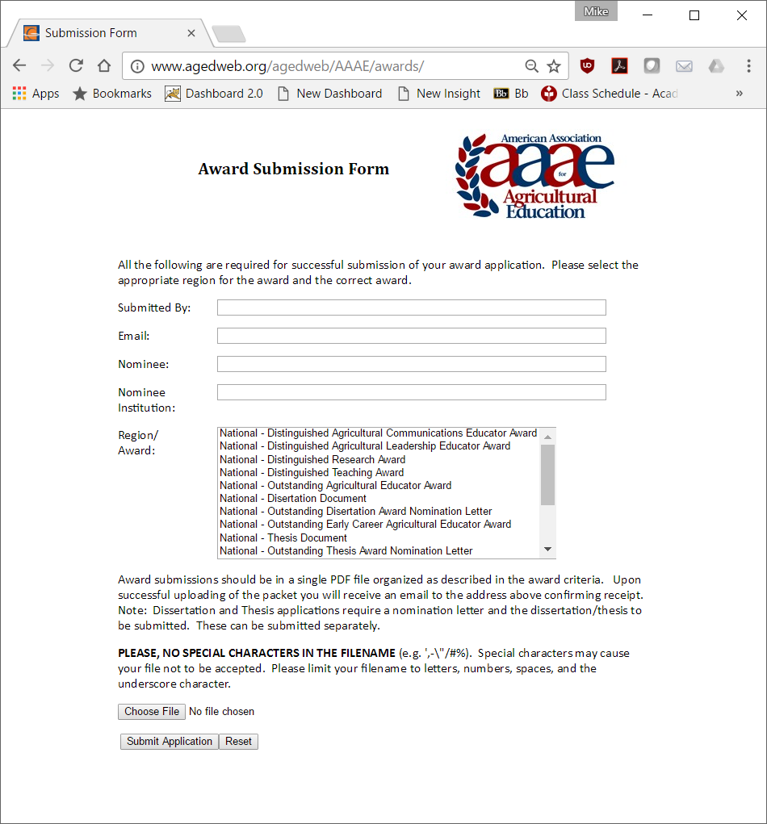

Admin Menu
http://www.agedweb.org/AAAE/awards/admin.asp
A password is required to access the admin functions. Admin functions allow the maintenance of the system, viewing, downloading, and deleting of submissions.
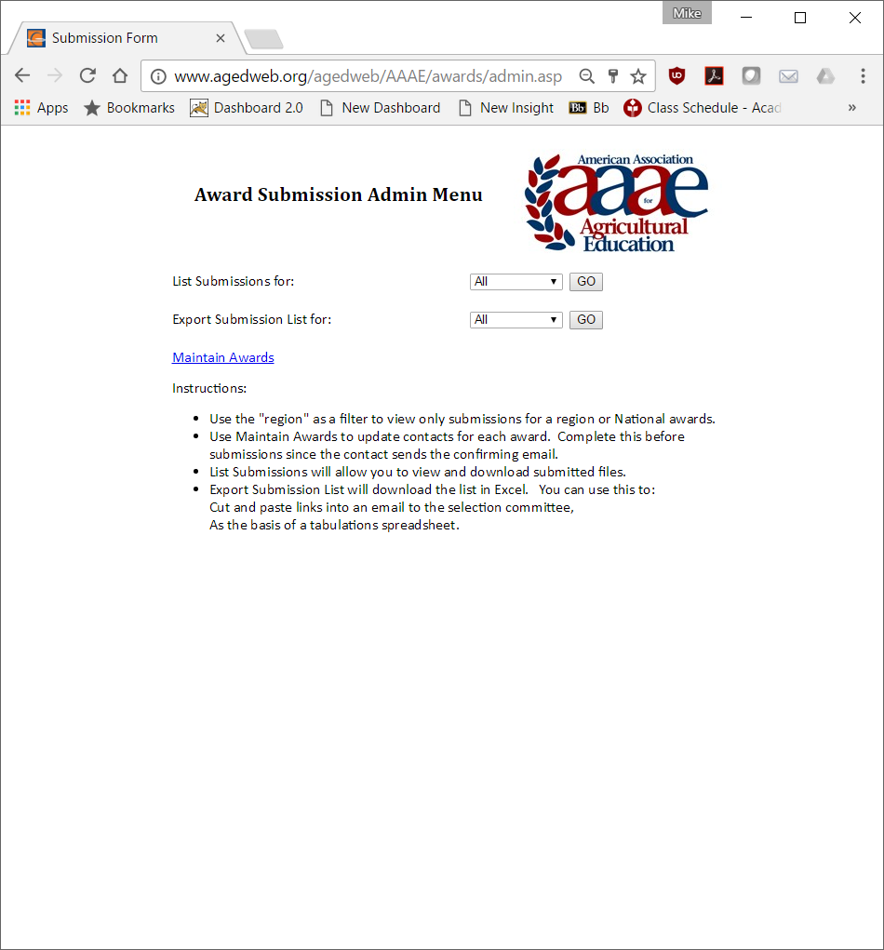

Submission List (admin)
Use this screen to view and download submissions. List can be filtered by region on the admin screen.
Before accepting submissions for the new year, old submissions can be deleted. Note that submissions are timestamped.
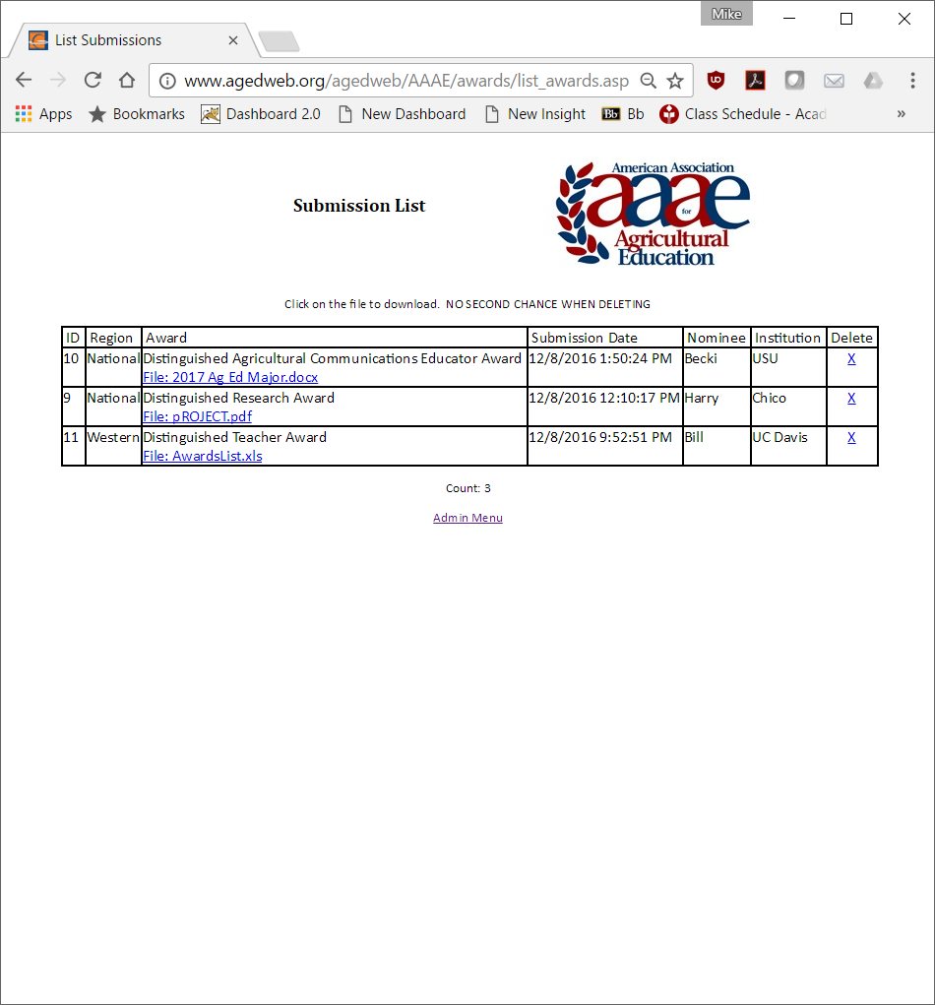

Maintain Awards (admin)
The main function of this screen is to maintain the contact information for the awards. The contact information is used to send confirmation emails to submitters. Award names can be edited and the display order (on the submission page) changed here as well. New awards are added here.
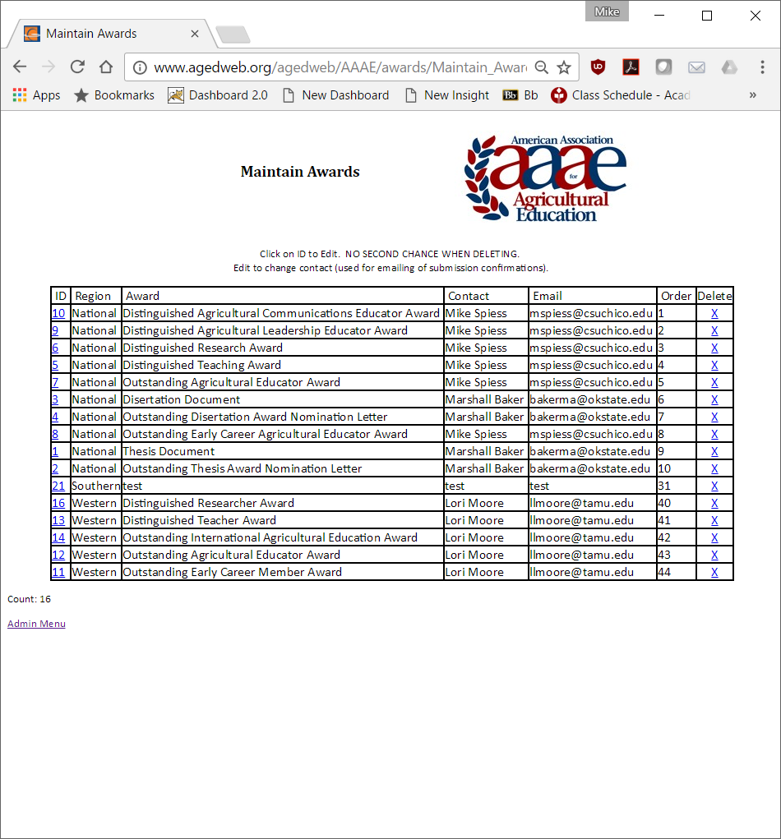

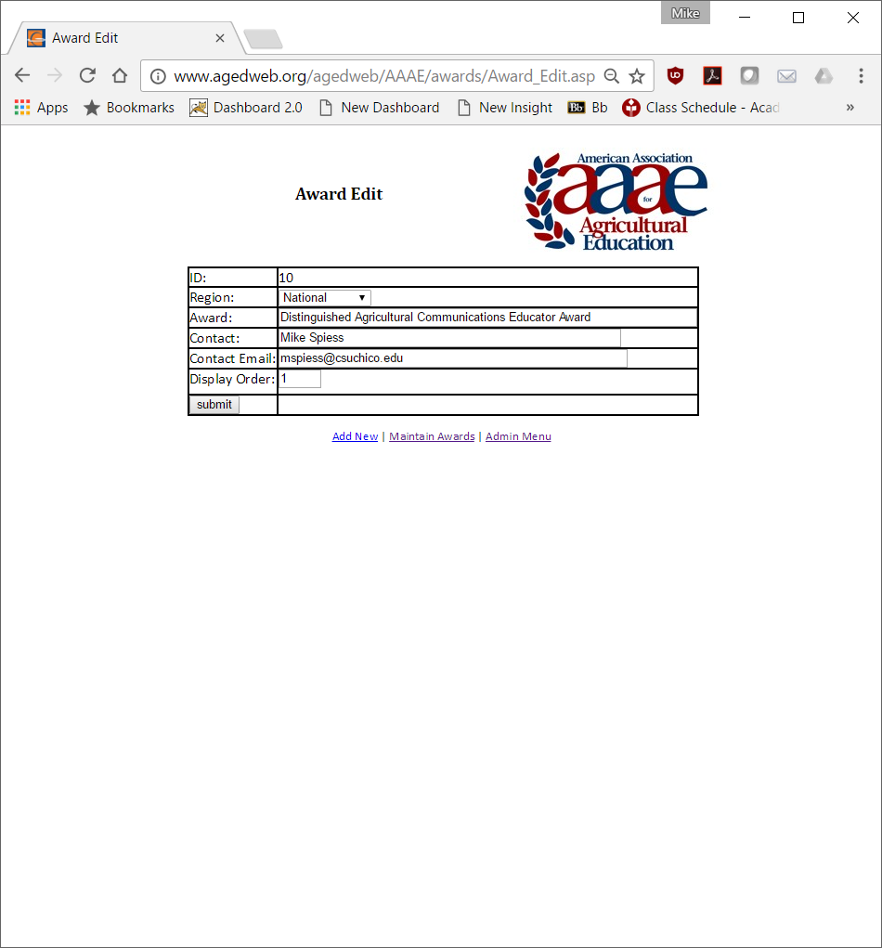

Sample Excel Spreadsheet (admin)
Submission data can be exported to Excel (by region). Cut and paste the highlighted columns into an email to the selection committee so they can access the submissions.
Region | Award | Submission Date | Submission ID | Nominee | Institution | Link
National | Distinguished Agricultural Communications Educator Award | 12/8/2016 13:50 | 10 | Becki | USU | http://www.agedweb.org/AAAE/awards/downloadfile.asp?ID=10
National | Distinguished Agricultural Communications Educator Award | 12/8/2016 12:10 | 9 | Harry | Chico | http://www.agedweb.org/AAAE/awards/downloadfile.asp?ID=9
National | Distinguished Agricultural Communications Educator Award | 12/8/2016 12:10 | 11 | Jean | Chico | http://www.agedweb.org/AAAE/awards/downloadfile.asp?ID=11

Sample Evaluation Spreadsheet
The sample below is based on the downloaded data above. The rankings are entered and summed. Low score is winner.
 |  |  | Committee Rank
Award | Nominee | Institution | Sally | Jim | Sue | TOTAL
Distinguished Agricultural Communications Educator Award | Becki | USU | 1 | 2 | 1 | 4
Distinguished Agricultural Communications Educator Award | Harry | Chico | 2 | 1 | 2 | 5
Distinguished Agricultural Communications Educator Award | Jean | Chico | 3 | 3 | 3 | 9

Appendix E – Conference Location Rotation
Year | Location
2017 | Colorado
2018 | Idaho
2019 | Wyoming
2020 | Montana
2021 | New Mexico
2022 | Utah
2023 | Alaska or Hawaii
2024 | California
2025 | Texas
2026 | Nevada
2027 | Oregon
2028
2029

Appendix F – Conference Registrations

Location | Year | Registered* | Paid** | Avg Registration**
TX | 2013 |  | 94 | $205
HI | 2014 |  | 73 | $409
OR | 2015 | 52 | 49 | $259
AZ | 2016 | 67 | 65 | $276
CO | 2017
ID | 2018
* Collected from AAAE online registration. Not available prior to 2015.
** Based on AAAE treasurers reports

Sample registration spreadsheet from AAAE online system. It may be used to “mail merge” name badges and other materials.
Event title | First name | Last name | College | Member | Guest registrations
2016 Western Region | Cassie | Graham | College of Agricultural Sciences and Natural Resources | Yes | –
2016 Western Region | Kasee | Smith | University of Idaho | No | –
2016 Western Region | Savanna | Barksdale | College of Agricultural Sciences and Natural Resources | No | –
2016 Western Region | Matt | Mars | University of Arizona | Yes | –
2016 Western Region | Mark | Balschweid | College of Agricultural Sciences and Natural Resources, University of Nebraska-Lincoln | Yes | –
2016 Western Region | Amber | Rice | University of Arizona | Yes | –

Appendix G – Supplemental Documents
Supplement documents can be found in the dropbox.
Folders exist for each conference, for each officer, and for the research and poster chairs. Officers and Chairs are encouraged to keep these documents current.

Appendix H – Research Proceedings Guidelines
Conference proceedings for the the research sessions are created by the Research Chair. The following describes the process for creating this document including the style and process. The document is compiled from parts, formatted, paginated, saved as a PDF file, bookmarked, and posted on the web site.
Parts:
Coverpage
List of past chairs
Summmary

Order- Papers should listed in presentation order. The list of abstracts can be used for the conference program.

Final abstrcts are inserted in to the docments.
Headers and Footers
Hyperlinks are useful to the reader in finding abstracts.
Hyperlinks can be made in one of two ways: In the word document or in the PDF document.
Sample file:
Appendix: Award certificates
A power point template is

Appendix H – Poster Session Guidelines
(append here as PDF)

http://jae-online.org/index.php/philosophy

