How to Register (ALL users) for NEW system
Journal of Agricultural Education via PKP platform

Greetings all,

We are transitioning to a new web hosting/publishing platform for the Journal of Agricultural Education (JAE). We are excited about this transition and opportunities it will provide. Every participant for the Journal of Agricultural Education must register through the new system.

The transition from Fasttrack to PKP will launch on January 1,2023. The old JAE website will still be available til June 1, 2023, to use for archival information but all new publications, manuscript submissions, reviews for JAE will be done through via PKP.

To get registered you will need to:
- Go to https://jae.sfulib4.publicknowledgeproject.org/
- In the upper right hand of the JAE web page, you will click “Register”
- The register page will allow you to setup your account. Please fill out all the information
- Once you complete the registration process you will be sent a confirmation email, please respond to it ASAP.
- Once you respond, you will be able to register and access the system.
- We are currently setting up the manuscript submission and review processes. Look for an informational instructional guide in the next week.

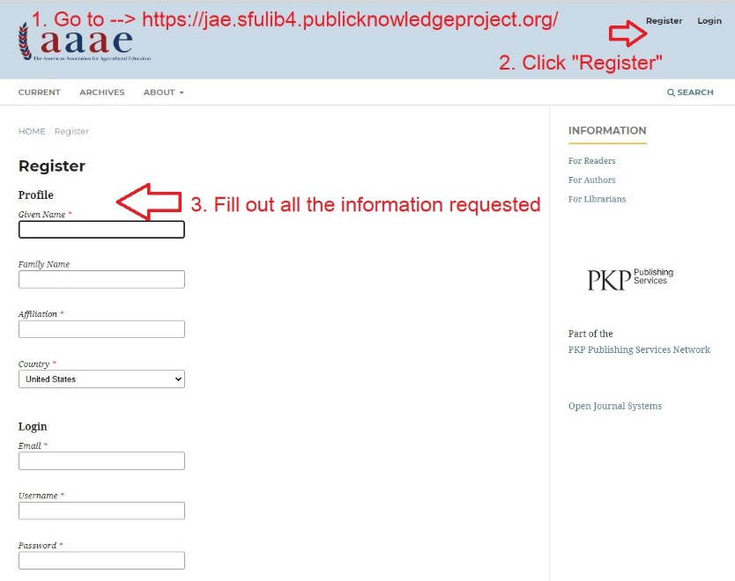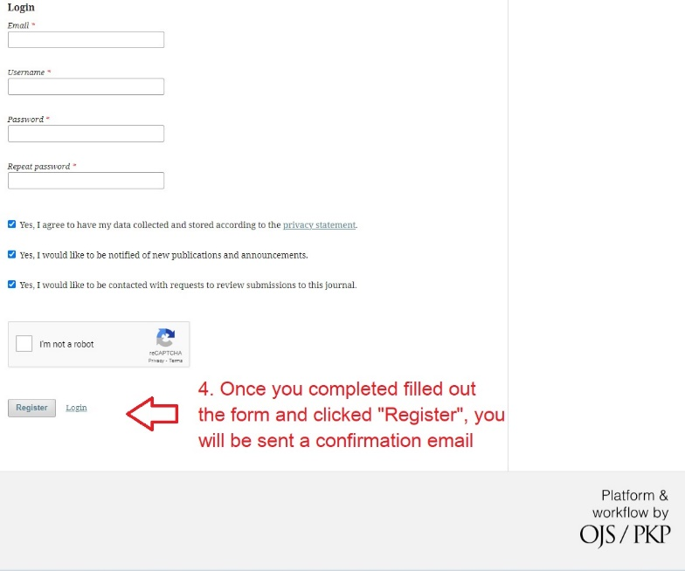

If you have any questions or concerns, please do not hesitate to email me at dedgar@nmsu.edu
Thank you for your time, efforts and commitment to moving our profession forward.

Don

