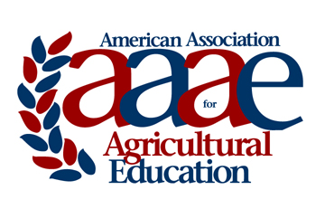 | Outstanding Dissertation Award  Award Criteria & Nomination Instructions  2019  *Updated to reflect changes approved at the 2017 AAAE Conference

Introduction:

The American Association for Agricultural Education has established a doctoral dissertation award program. The program is designed to recognize the doctoral student who has completed the most outstanding dissertation during the previous calendar year. Each doctoral degree granting institution awarding a Ph.D. or Ed.D. from a department of Agricultural or Extension Education or similar is eligible to submit one outstanding dissertation nominee each year.

This award has been made possible by funds provided by Dr. Susie Whittington. Contributions in support of this program should be sent to the AAAE Treasurer and designated for the Outstanding Dissertation Award fund.

Eligibility:

Doctoral students completing a dissertation with a defense date during the calendar year of 2018 are eligible for consideration for the 2019 award.
- Only one nomination will be accepted per institution each year. Each institution is responsible for the procedures by which their nominee is selected.
- Doctoral student must be a member (student or active) of AAAE in order to be eligible for the award.

Format:

The submission will be a full dissertation.

Procedures:

A letter of nomination from the nominee’s advisor (co-signed by the departmental administrator) should be addressed to: AAAE Outstanding Dissertation Selection Committee and uploaded with the paper to the award nomination website at http://www.agedweb.org/AAAE/awards/. A member login is required to upload.

Nominations must be received by January 2nd to be considered for the award presented at the AAAE annual meeting in May each year.

Judging and Awards:

- Judging and selection of the award recipient will be conducted by a committee of AAAE fellows.
- Faculty advisors of the nominees are ineligible to serve on the selection committee.
- A plaque and a check for $500 will be presented to the recipient and a certificate presented to the award recipient’s faculty advisor at the AAAE annual meeting.

Selection Criteria | Point Value
A. Problem Statement | 10
B. Theoretical Framework | 10
C. Research Design/Procedures | 10
D. Data Analysis Technique(s) | 10
E. Findings | 10
F. Conclusions | 20
G. Recommendations/Implications | 20
H. Value to Agricultural Education | 10
Total Points Possible | 100

For questions, please contact the Chair of the AAAE Research Committee:
Dr. Alexa Lamm
University of Georgia - Athens
alamm@uga.edu
706-583-0072

