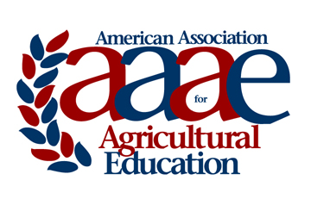 | AAAE – Southern Region  DISTINGUISHED RESEARCHER  Award Criteria & Nomination Instructions  2019

Purpose:

To recognize individual AAAE-Southern Region members for outstanding research conducted by them that contributes in a superior manner to the Agricultural Education profession. All award nominees will have been in Southern Region the three years prior to the award being given and must be a continuous dues paying member for five years preceding when the award is given.

Nomination and Selection Procedures

- The nomination may be made by a colleague of the nominee. Self-nominations are also accepted.
2. Nominations must be submitted by email to Dr. Tracy Rutherford by 11:59pm, January 2, 2019.

Criteria for Selection

- The nominee must be an active member of the AAAE who has maintained continuous membership in the association.
- Nominees should have sustained a program of research for at least ten years.
- Selection will be based on documentation of outstanding research accomplishments.
- Candidate’s statement concerning their research focus, research priorities, and actual or anticipated impact on theory and/or practice, not to exceed two typewritten (12 point, Times font) single-spaced pages.
- Evidence of excellent in research should include:
  - Proof of frequent, consistent and important contributions to the knowledge base in Agricultural Education broadly defined as documented by a list of publications and presentations.
  - Recognition through such things as previous research awards, invited presentations, extramural funding, service on grant panels, service as a journal editor, and service on editorial review boards as documented by a list of recognitions.
  - Providing leadership for major research initiatives on a regional, national, or international level as documented by the candidate’s statement and/or a list of contributions.
- Impact as a research mentor for graduate students, post docs, and early career faculty. This will be documented by two letters of reference from individuals who are familiar with the candidate’s research abilities (such as protégés, professional colleagues, etc.), limited to one single spaced typewritten page for each letter.

Nomination Materials

Nomination packets must include and shall be limited to:

- Cover sheet (see next page).
- Evidence of excellence in research (items from #5 above), limited to three pages total.

AAAE – SOUTHERN REGION

DISTINGUISHED RESEARCHER

COVER SHEET
Name of Nominee:
Institution:
Title:
Professional Employment Record:

Degrees Held:

Nomination Submitted by:
Contact information for nominator:

Nomination packets limited to cover sheet and evidence of excellence in research. Nomination should be saved as one PDF document and emailed no later than 11:59 pm, January 2, 2019 to trutherford@tamu.edu
For questions and submission, contact:
Dr. Tracy Rutherford
Texas A&M University
trutherford@tamu.edu
979-458-2744

